**SITE MONITORING TOOL**

This task is basically dedicated to create a website monitoring tool to check whether is website is available to use or not.

I basically wrote the code in python importing requests library and added a list of URLs to check upon. The function check_website_status(url) picks up a url and sends a HTTP GET Request to it and waits till 5 seconds to fetch the data, if the status code is 200 then it displays the Website is UP else its DOWN. It also checks for exception if any and prints the exception.

HTTP GET Request:

An HTTP GET request is a fundamental method used in the Hypertext Transfer Protocol (HTTP) to retrieve data from a server. When a client, such as a web browser or an application, sends a GET request, it asks the server to provide a specific resource, like a web page, an image, or data from an API. The server processes this request and, if the resource is available, returns it along with a status code indicating the outcome (e.g: 200 for success, 404 for not found). GET requests are primarily used for data retrieval and do not modify anything on the server.

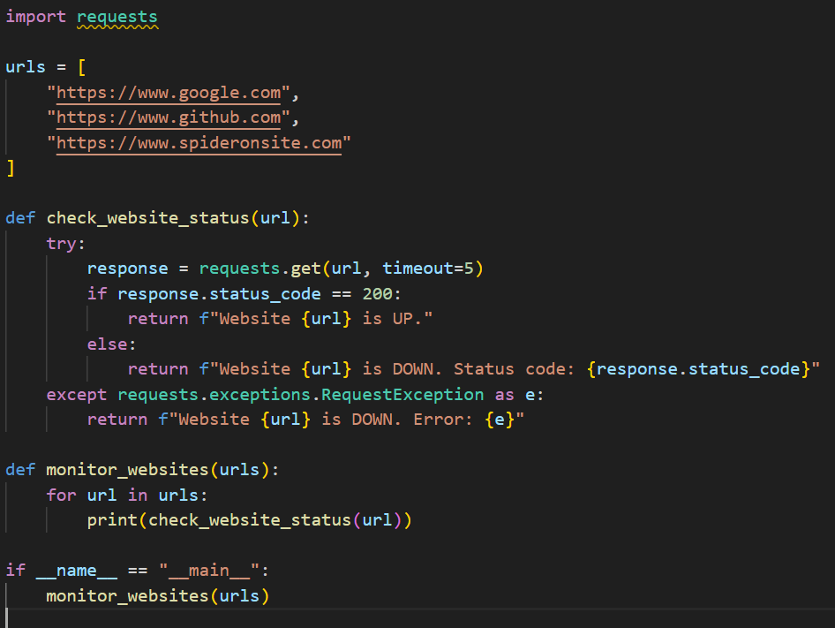

Running this python script in CMD

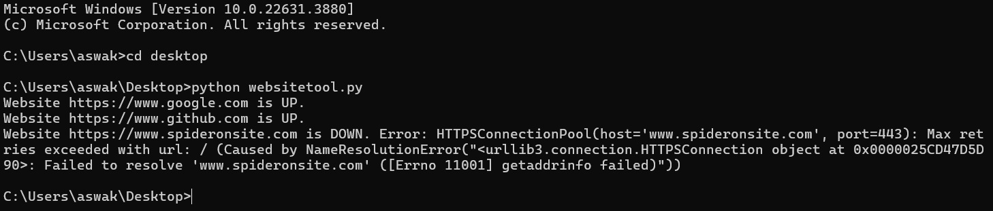

Since the website spideronsite.com doesn’t exist it raises a Name Resolution error.